JSON FORMATTER TOOL

This Utility is used to convert static data values into JSON format for CPS 1.5 Compressor MAB and Compressor WGC curves and CPS 2.0 DMDS Curves.

This Tool is Developed in Python using the following Libraries:-

* PyQt5, QtDesigner tool to create the UI
* Pandas and xlrd to read excel file and perform operations on the data
* JSON library to create the JSON format
  1. **Tool Installation.**

1. Download the ZIP from the GES Visualization Teams folder at this location

<https://teams.microsoft.com/_#/files/General?threadId=19%3Adbddbf7a5a8e45dd87d350dde802230f%40thread.tacv2&ctx=channel&context=JsonFormatterTool&rootfolder=%252Fteams%252FGESVisualisationTeam%252FShared%2520Documents%252FGeneral%252FJsonFormatterTool>

1. Install the tool using .exe file.

STEPS To Use the Tool

1. After adding the Static values and Tag Names in Configuration.xlsx file , Select the file.
2. Select the Start Timestamp.
3. Select the Graph Type from Dropdown for which you want to create the JSON format.
4. After clicking on Download the json format Text file will be saved in the same folder where the tool is kept.

* 1. **Configuration File**

**NOTE :- Do NOT** change the Column Names and Sheet Names present in the Configuration File

1. MAB Graphs Configuration 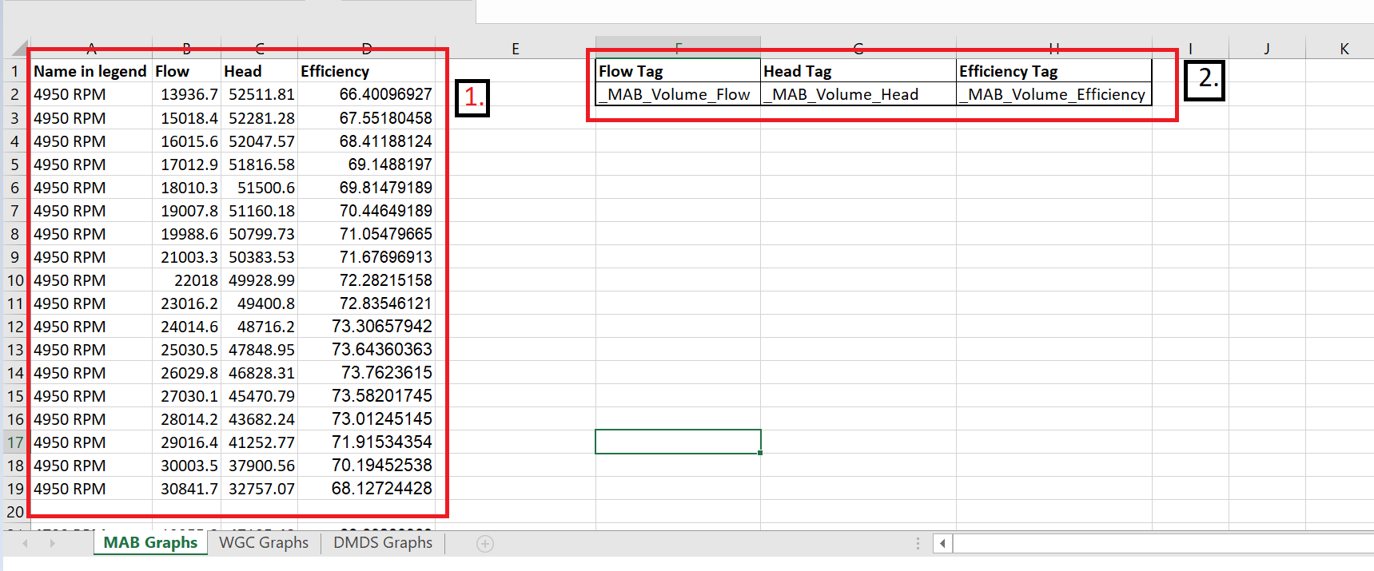

* Put Static values for Flow, Head and Efficiency in the respective columns in table 1
* In “Name In Legend” Column Add the complete name (as shown in the image above) for all the values belonging to that name in **all the rows** in table 1
* To add set of values for another Legend name leave a row blank and then add the values after that row.
* In Table 2 Add the Tag names for Flow, Head and Efficiency.

1. WGC Graphs Configuration

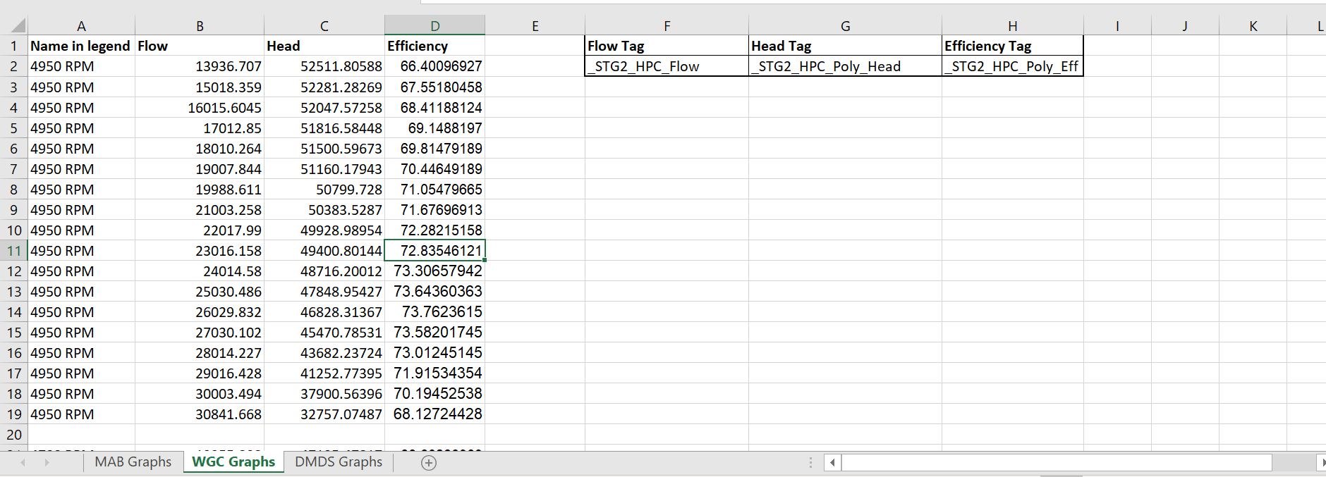

* Put Static values for Flow, Head and Efficiency in the respective columns in table 1
* In “Name In Legend” Column Add the complete name (as shown in the image above) for all the values belonging to that name in **all the rows** in table 1
* To add set of values for another Legend name Leave a row blank and then add the values after that row.
* In Table 2 Add the Tag names for Flow, Head and Efficiency.

1. DMDS Graphs Configuration

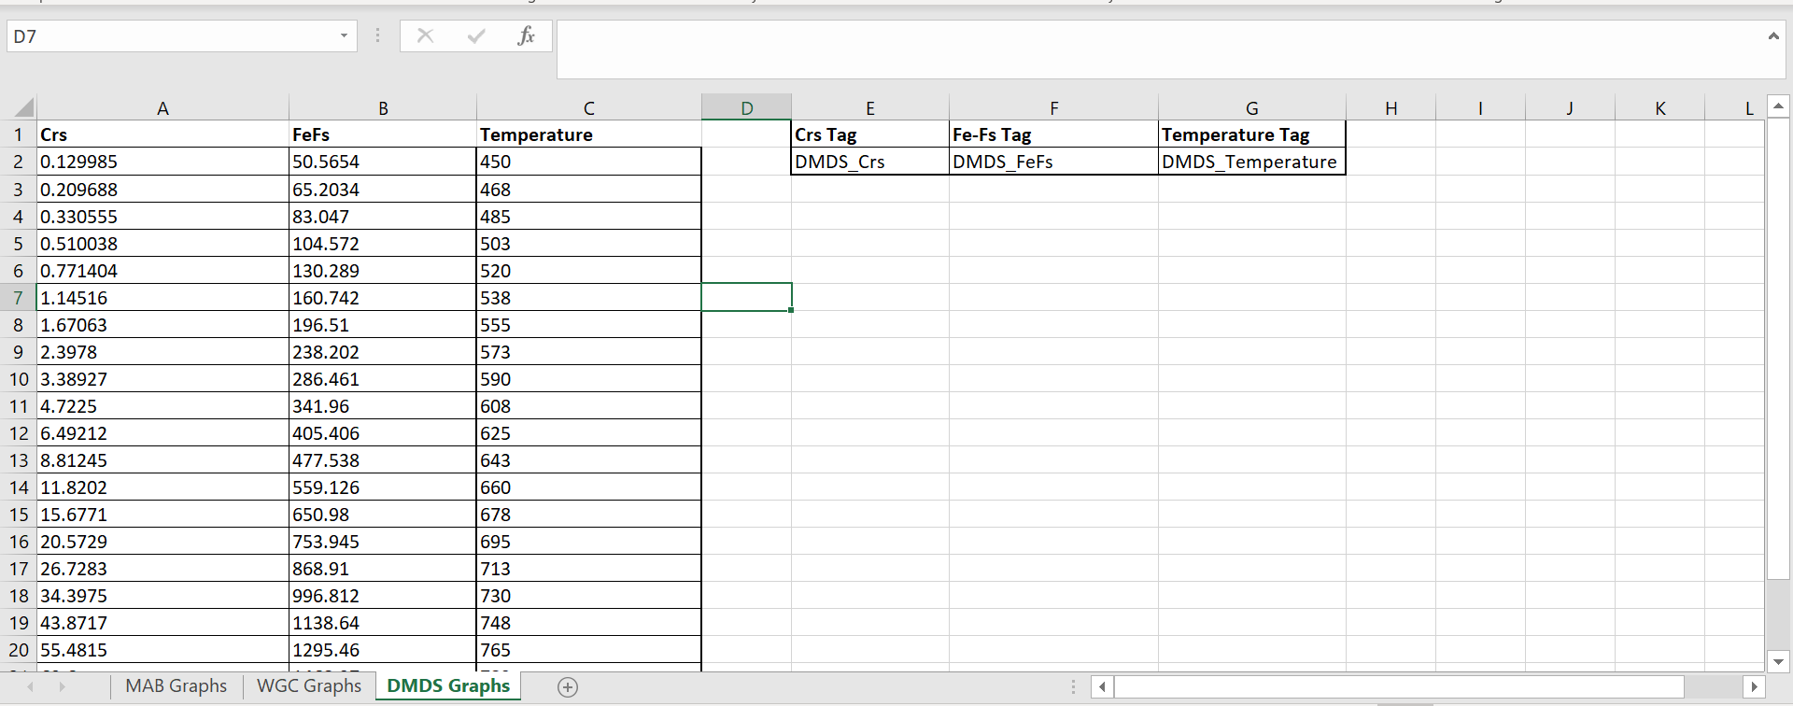

* Put Static values for Crs, FeFs and Temperature in the respective columns n table
* Add the Tag names for Crs, FeFs and Temperature